**HORMISDALLEN SCHOOL - KYEBANDO**

**PRE-PLE SET 1 EXAMINATION, 2023**

**PRIMARY SEVEN SCIENCE**

Duration: 2 Hours 15 Minutes

**NAME: ______________________________________________ STREAM: ___________**

EMIS NO.

INDEX NO.

**SECTION A (40 MARKS)**

1. Identify any one example of a material which can be attracted by a magnet.

__________________________________________________________________________________

1. Mention any **one** example of an egg laying mammal.

__________________________________________________________________________________

1. Which disorder of the skeletal muscular system is caused when one gets in contact with hot water?

__________________________________________________________________________________

1. Identify any **one** breed of sheep that is useful to the textile industry.

_________________________________________________________________________________

1. What do we call a place in the body where two or more bones meet?

_________________________________________________________________________________

1. Why are parents advised to take their children for immunization?

__________________________________________________________________________________

1. Give any **one** mode of a sexual reproduction in living things.

__________________________________________________________________________________

1. How can the pitch of a stringed musical instrument be increased?

__________________________________________________________________________________

1. Why should electricians use properly insulated wires during installation of electricity?

__________________________________________________________________________________

1. How can a farmer maintain soil moisture in a banana plantation?

___________________________________________________________________________________

1. Why are laying nests put in dark corners in a poultry house?

___________________________________________________________________________________

___________________________________________________________________________________

1. How do mechanics reduce the force that opposes motion in moving parts of a car?

__________________________________________________________________________________

1. Using an arrow show the direction of movement of the diaphragm during inhalation?

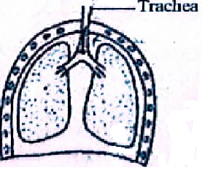

1. What condition results from shortage of oxygen supply to the brain?

___________________________________________________________________________________

1. An electromagnet is a magnet made using electrical method. How can its strength be increased? ___________________________________________________________________

___________________________________________________________________________________

1. In the space below draw a beak of a nectar sucking bird.
2. State **one** importance of hoof trimming in goat rearing.

___________________________________________________________________________________

1. Reflection of light is the bouncing back of light. How is this property important in our daily life? __________________________________________________________________

___________________________________________________________________________________

1. Name any one process that takes place in plants.

___________________________________________________________________________________

1. State **one** effect of heat loss in liquids.

___________________________________________________________________________________

1. State any **one** way a honey harvester protects himself against bee stings.

___________________________________________________________________________________

1. Give any **one** description of images formed in a pinhole camera.

__________________________________________________________________________________

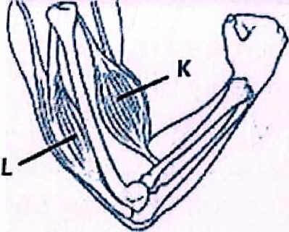**Study the diagram below and use it to answer the questions 23 and 24.**

1. Name the muscle marked **L**.

______________________________________________

1. Why are muscles **K** and **L** called voluntary muscles?

_________________________________________________________________________________

1. By looking at a crop in the garden, how can you tell that it is a legume crop without uprooting it?

__________________________________________________________________________________

1. Why should a living house have windows, doors and ventilators?

__________________________________________________________________________________

1. Give the importance of plants in a food chain.

___________________________________________________________________________________

1. State **one** reason why farmers spray tomato plants in the garden using chemicals.

___________________________________________________________________________________

1. Why are people encouraged to use energy saving bulbs instead of the ordinary bulbs?

___________________________________________________________________________________

1. Apart from being pregnant, give any **one** condition in which women are vulnerable.

__________________________________________________________________________________

1. How are black flies a threat to human health in the environment?

__________________________________________________________________________________

1. Identify any **one** health habit a small child can learn from a big child at home.

___________________________________________________________________________________

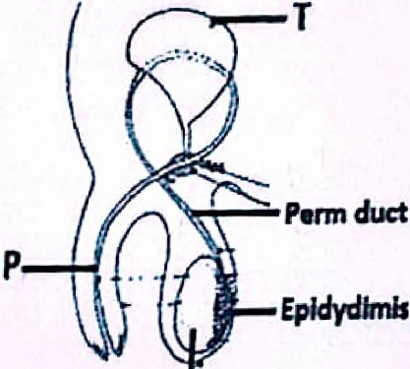**Study the diagrams below carefully and use them to answer questions 31 and 32.**

**B**

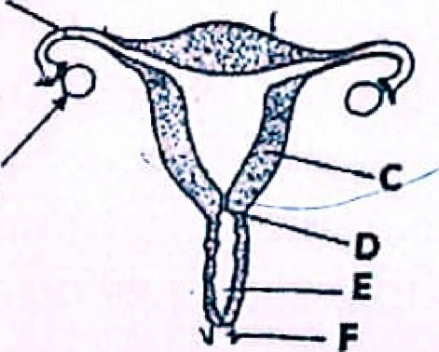

**A**

1. Identify **one** process that takes place in part marked **B**.

___________________________________________________________________________________

1. In which way is part marked **A** different from part marked **Q** in their reproductive function?

____________________________________________________________________________________

1. Why is wood prepared for making charcoal covered with soil before burning?

____________________________________________________________________________________

1. How do plants benefit from the practice of keeping bees in the same locality?

____________________________________________________________________________________

1. Joy is a chef at Sunset hotel in Kisumu city. State any **one** reason why she adds iodized salt in the food during preparation?

________________________________________________________________________________________

1. What force enables insects to float on water?

___________________________________________________________________________________

1. Why are people encouraged to always perform body physical exercises?

___________________________________________________________________________________

1. Identify any **one** practice carried out on a farm that helps in proper identification of animals.

___________________________________________________________________________________

**SECTION B**

1. a) Mention any **two** diseases that affect poultry on a farm.
2. ___________________________________________________________________________________

(ii) ___________________________________________________________________________________

b) State any **one** effect of poultry diseases to a farmer.

_________________________________________________________________________________

c) In which **one** way can a farmer safeguard his poultry against diseases on a farm?

____________________________________________________________________________________________

1. a) Name the part of a mosquito it uses to get its food.

______________________________________________________________________________

b) State any **three** ways how the spread of malaria can be prevented.

(i) ____________________________________________________________________________________

(ii) ___________________________________________________________________________________

(iii) ____________________________________________________________________________________

1. a) Give any **two** examples of crops which produce grains.

(i) __________________________________________________________________________________

(ii) __________________________________________________________________________________

b) Write down any **two** ways farmers can care for crops in the garden.

i) _______________________________________________________________________________

ii) _______________________________________________________________________________

1. The diagram below shows a ray of light striking a plane mirror and how it is reflected. Use it to answer the questions that follow.

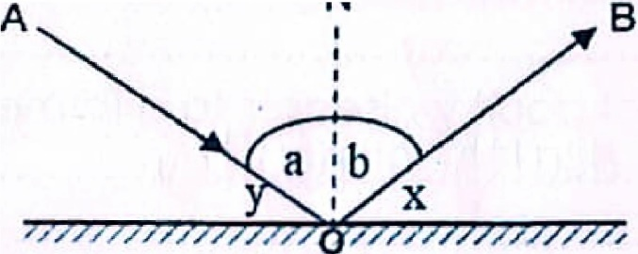 **N**

**Plane mirror**

a) Name the angle marked ‘a’

_____________________________________________________________________________

b) which type of reflection is shown in the diagram above?

___________________________________________________________________________________

c) Calculate the size of angle **‘a’** if angle **‘y’** is **42** degrees.

1. (a) What do we call components of the environment that are used to produce useful energy?

____________________________________________________________________________________

(b) Outline any two examples of the components of the environment mentioned in ‘a’ above.

(i) ____________________________________________________________________________

(ii) ____________________________________________________________________________

1. Define the term **“extinction”**

__________________________________________________________________________________________________________________________________________________________________

1. a) Give the type of movable joint found at:
2. The elbow: ________________________________________________________________________
3. The wrist: __________________________________________________________________
4. Give any **one** infection of the muscular skeletal system in humans.

_____________________________________________________________________________

1. How is the practice of performing regular physical exercises important to the muscular skeletal system?

________________________________________________________________________

1. **The diagram below shows a simple machine. Use it to answer the questions that follow.**
2. Name this simple machine.

_________________________________________

1. To which group of simple machines does it belong?

_________________________________________________

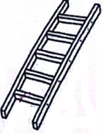

1. Give **one** other example of a simple machine that belongs to the same group as the one above.

________________________________________________________________________________

1. State any **one** advantage of using simple machines in our daily life.

__________________________________________________________________________

1. a) What happens to the air we breathe when it enters the nose?

______________________________________________________________________________

b) How is the trachea adapted to its function?

____________________________________________________________________________________

1. Identify any **one** disease of the respiratory system which is:
2. Communicable ___________________________________________________
3. Non-communicable _______________________________________________
4. a) State any **one** property of magnets.

______________________________________________________________________________

b) Point out any **two** ways a magnet can be weakened.

1. ________________________________________________________________________
2. _______________________________________________________________________

c) How are magnets useful in hospitals?

_____________________________________________________________________________________

1. (a) Why is the filament of a bulb coiled?

__________________________________________________________________________________________

(b) Suggest any **two** reasons why a bulb may fail to produce light when the switch is closed?

(i) ______________________________________________________________________________

(ii) _______________________________________________________________________________

(c) State any **one** effect of short circuits  
 ________________________________________________________________________________________

1. The diagram below shows a body organ. Use it to answer the questions that follow.

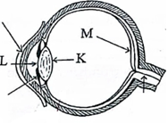

1. Name the part marked **K**.

________________________________

1. State the function of part marked **R**. ____________________________________

____________________________________

**Cornea**

**Iris**

**R**

c) Name any **two** diseases which affect the above body organ.

(i) ____________________________________________________________________________

(ii) __________________________________________________________________________

1. (a) State any **one** advantage of using a top bar hive

_________________________________________________________________________________

(b) Mention any **two** types of honey bees

1. _____________________________________________________________________
2. ________________________________________________________________________
3. State any **one** reason why bees can move from one hive to another.

__________________________________________________________________________________

1. (a) Why is breast milk regarded as a complete meal?

________________________________________________________________________________________

(b) Which food nutrient is lacking in breast milk?

________________________________________________________________________________________

(c) Why are the mammary glands in males not able to secrete milk?

________________________________________________________________________________________

1. Suggest any **one** reason why a baby may be introduced to bottle feeding.

_______________________________________________________________________________________

1. a) Briefly explain the meaning of the following terms.
2. Drug prescription _______________________________________________________________

___________________________________________________________________________________

(ii) Drug abuse ______________________________________________________________________

___________________________________________________________________________________

b) Give **two** examples of narcotic drugs.

i) ________________________________________________________________________________

ii) ________________________________________________________________________________

1. Match the types of electricity to their sources.

**Types of electricity Sources**

(i)Thermal electricity Uranium

(ii)Hydroelectricity Fossil fuels

(iii)Geothermal electricity Sun

(iv)Nuclear electricity Fast flowing water

Hot springs

1. Thermal electricity __________________________________________________________________
2. Hydroelectricity ____________________________________________________________________
3. Geothermal electricity _______________________________________________________________
4. Nuclear electricity ___________________________________________________________________